# Isys2160 LocalShop User Manuals

Setting Up (in local environment only, planned to be deployed later if possible)

Download the code submitted in canvas or pull from the following github repository: <https://github.com/hjparrk/localshop>

Open 2 terminal, 1 in the backend folder and another in the frontend folder

Type ”npm i” to install modules in each terminal, when starting the project for the first time.

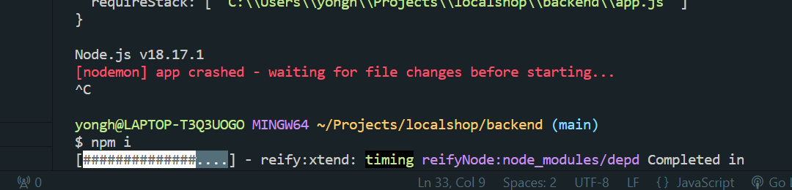

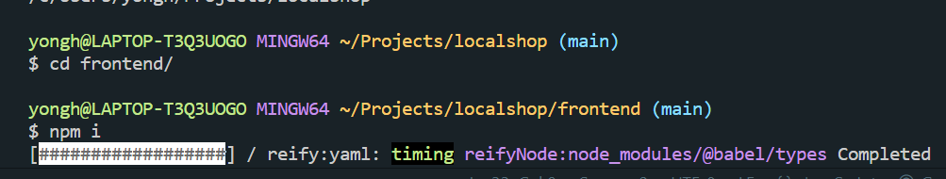

Type “npm start” in both terminals to launch both the frontend and backend, the link to the website is shown in the terminal of the frontend folder.

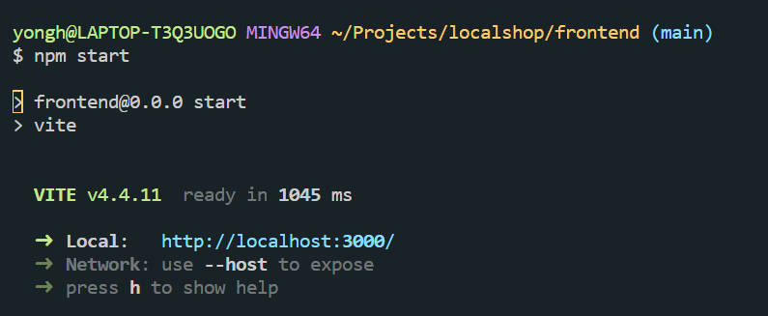

Exploring Our Website

When not logged in, users can see the home page with products.

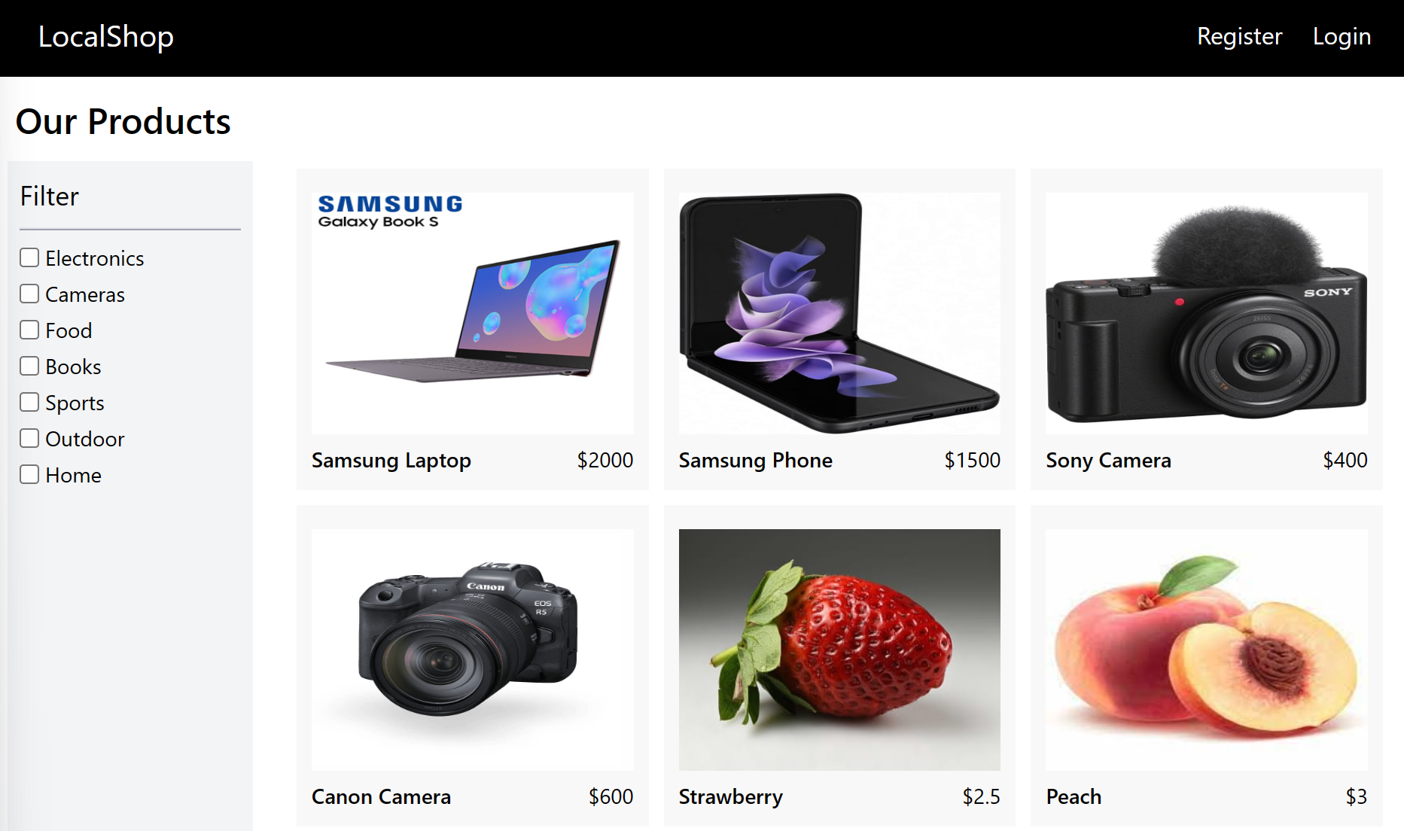

They can apply a filter to see products of the same category, filters work without authorisation.

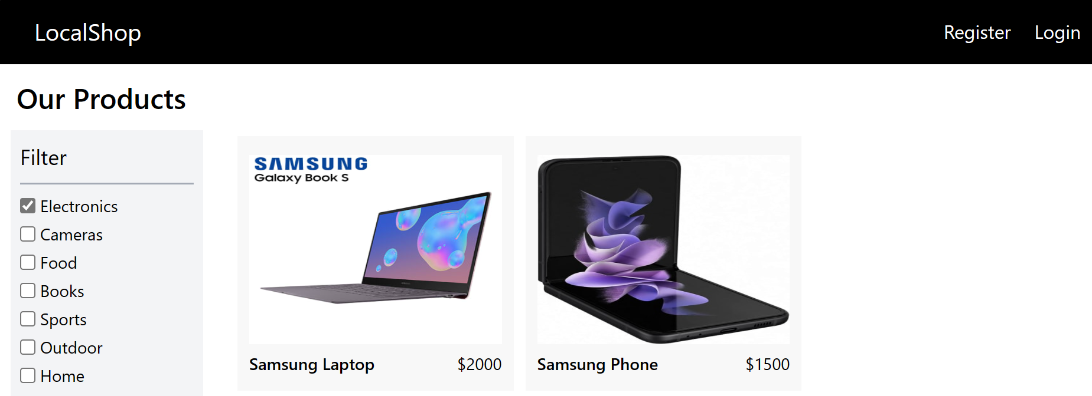

Users can click on each product to see the detailed description, though they cannot add to cart until they login.

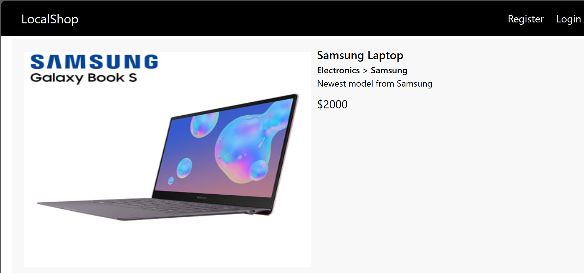

They can navigate using the headers and access the Register and Login page to authenticate and authorise themselves.

After which, depending on roles, they can do different things.

## Normal Users

* View Products:
  + Normal users can see the home page with products.

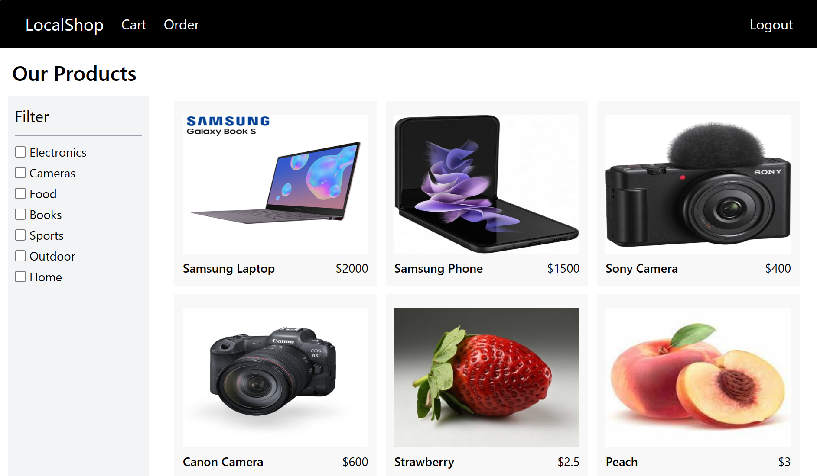

* + They can click on each product to see detailed information.

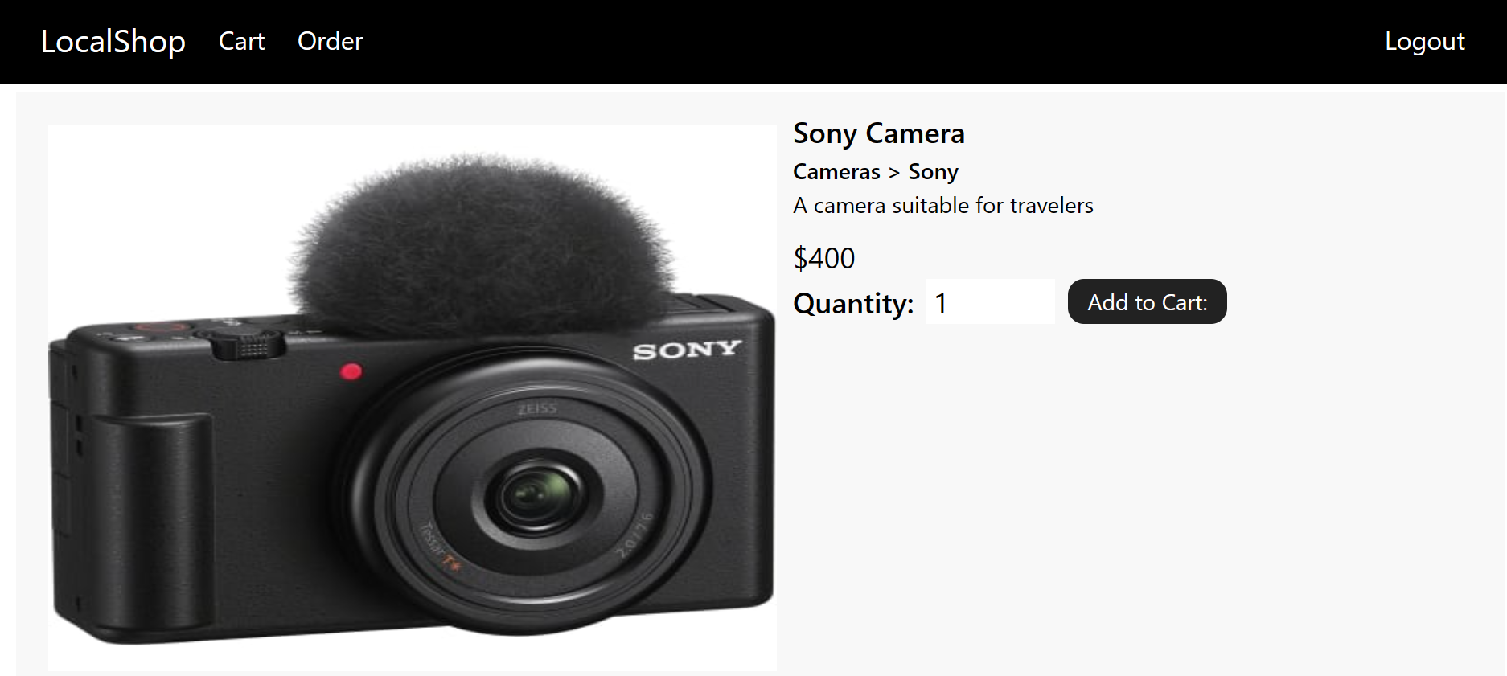

* Add to Cart:
  + They can click on each product to modify the quantity and add it to cart by clicking the “Add to cart” button.

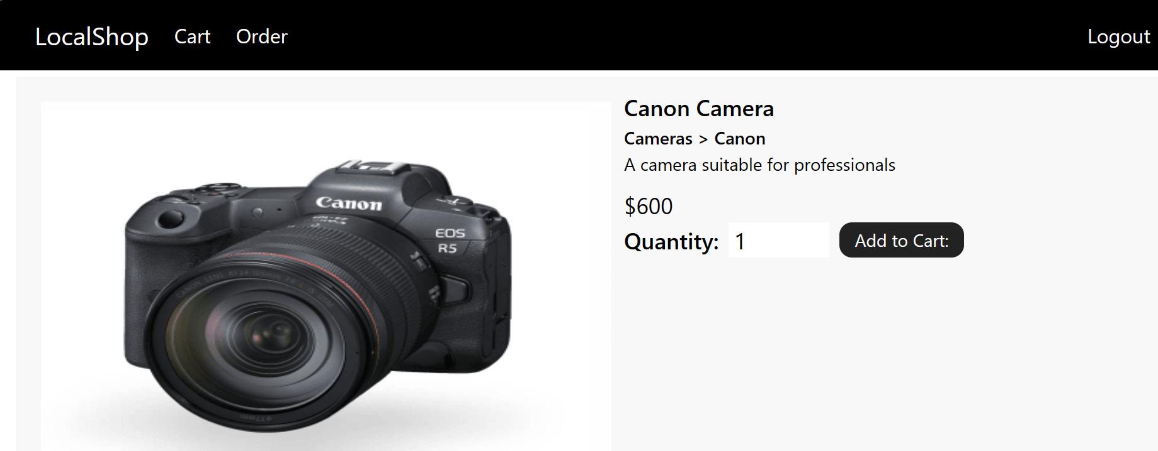

* + They can navigate to the cart by clicking the “Cart” on the header to see their added products, modify quantities, remove items, the total amount and checkout.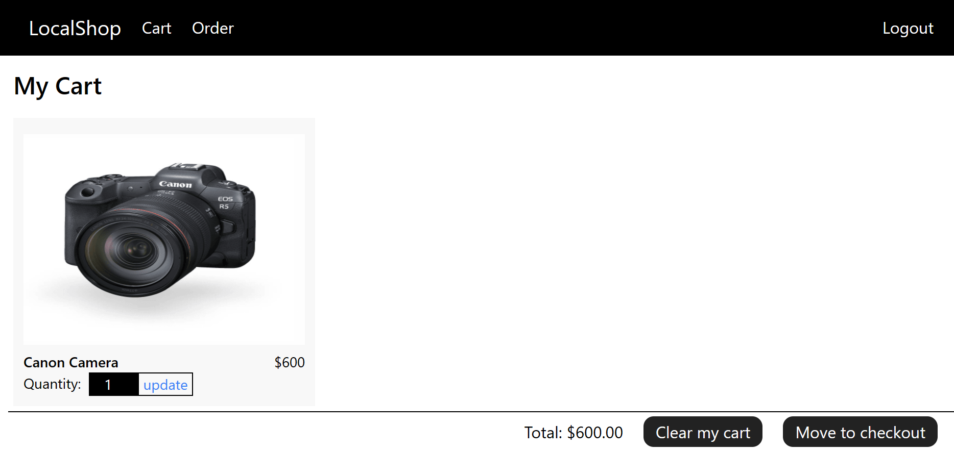
* Update Cart:
  + They can update the quantity of each product by clicking the quantity and typing the desired quantity and hitting the “update” button.

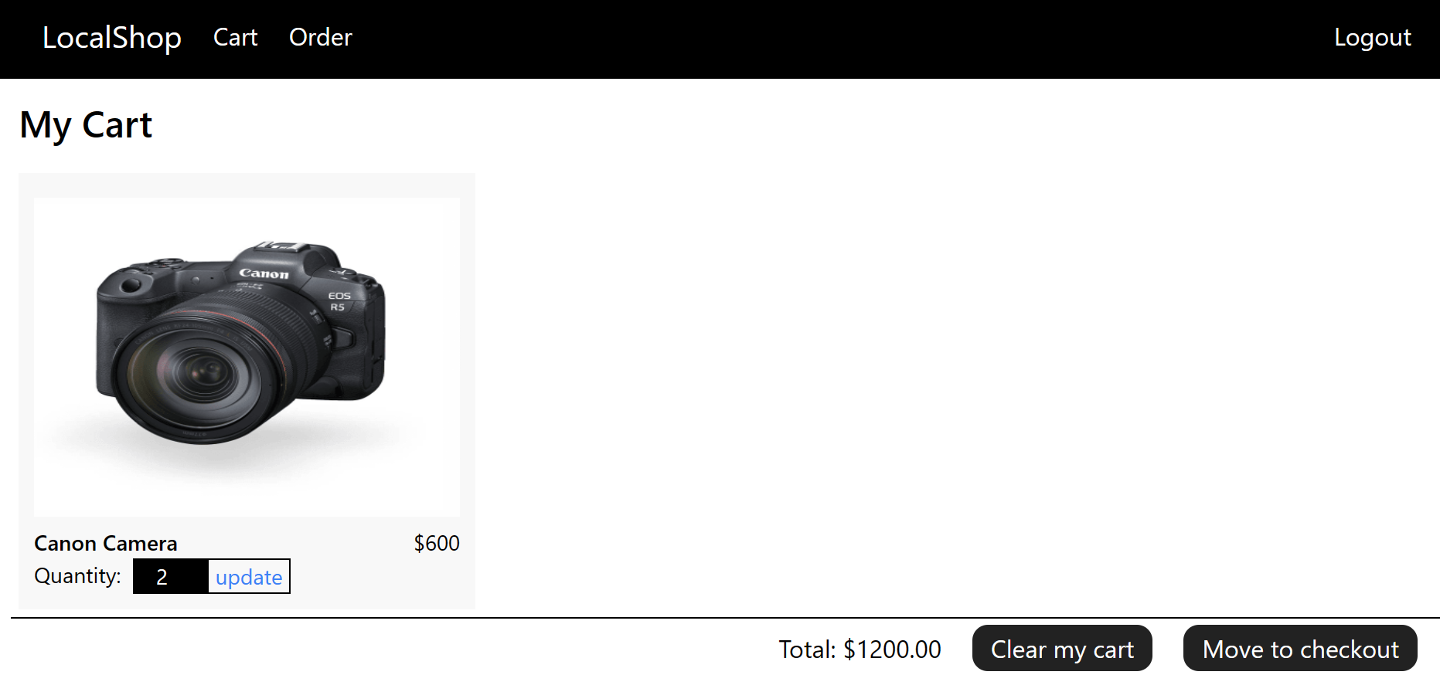

* + Or clear the whole cart with the “Clear my cart” button.

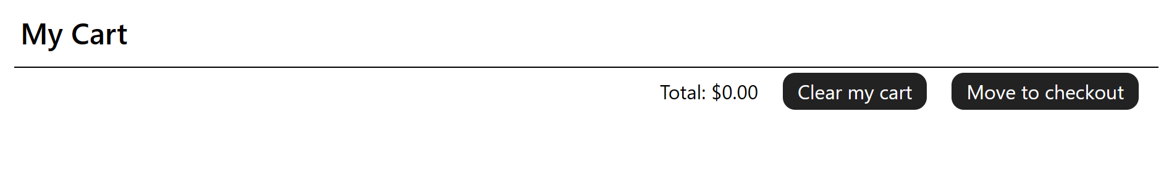

* Pay:
  + They can access the payment gateway by clicking the button “Checkout” on the cart page, which redirects them to the Stripe payment gateway.

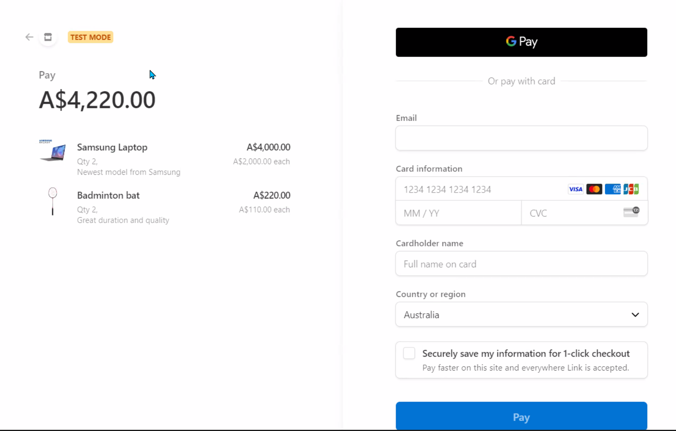

* + They can then enter information to allow payment. For the testing purpose, this only accepts the card information exactly as below, others won’t be accepted. They can then click “Pay” to complete the transaction, which redirects them back to the application with a success message.

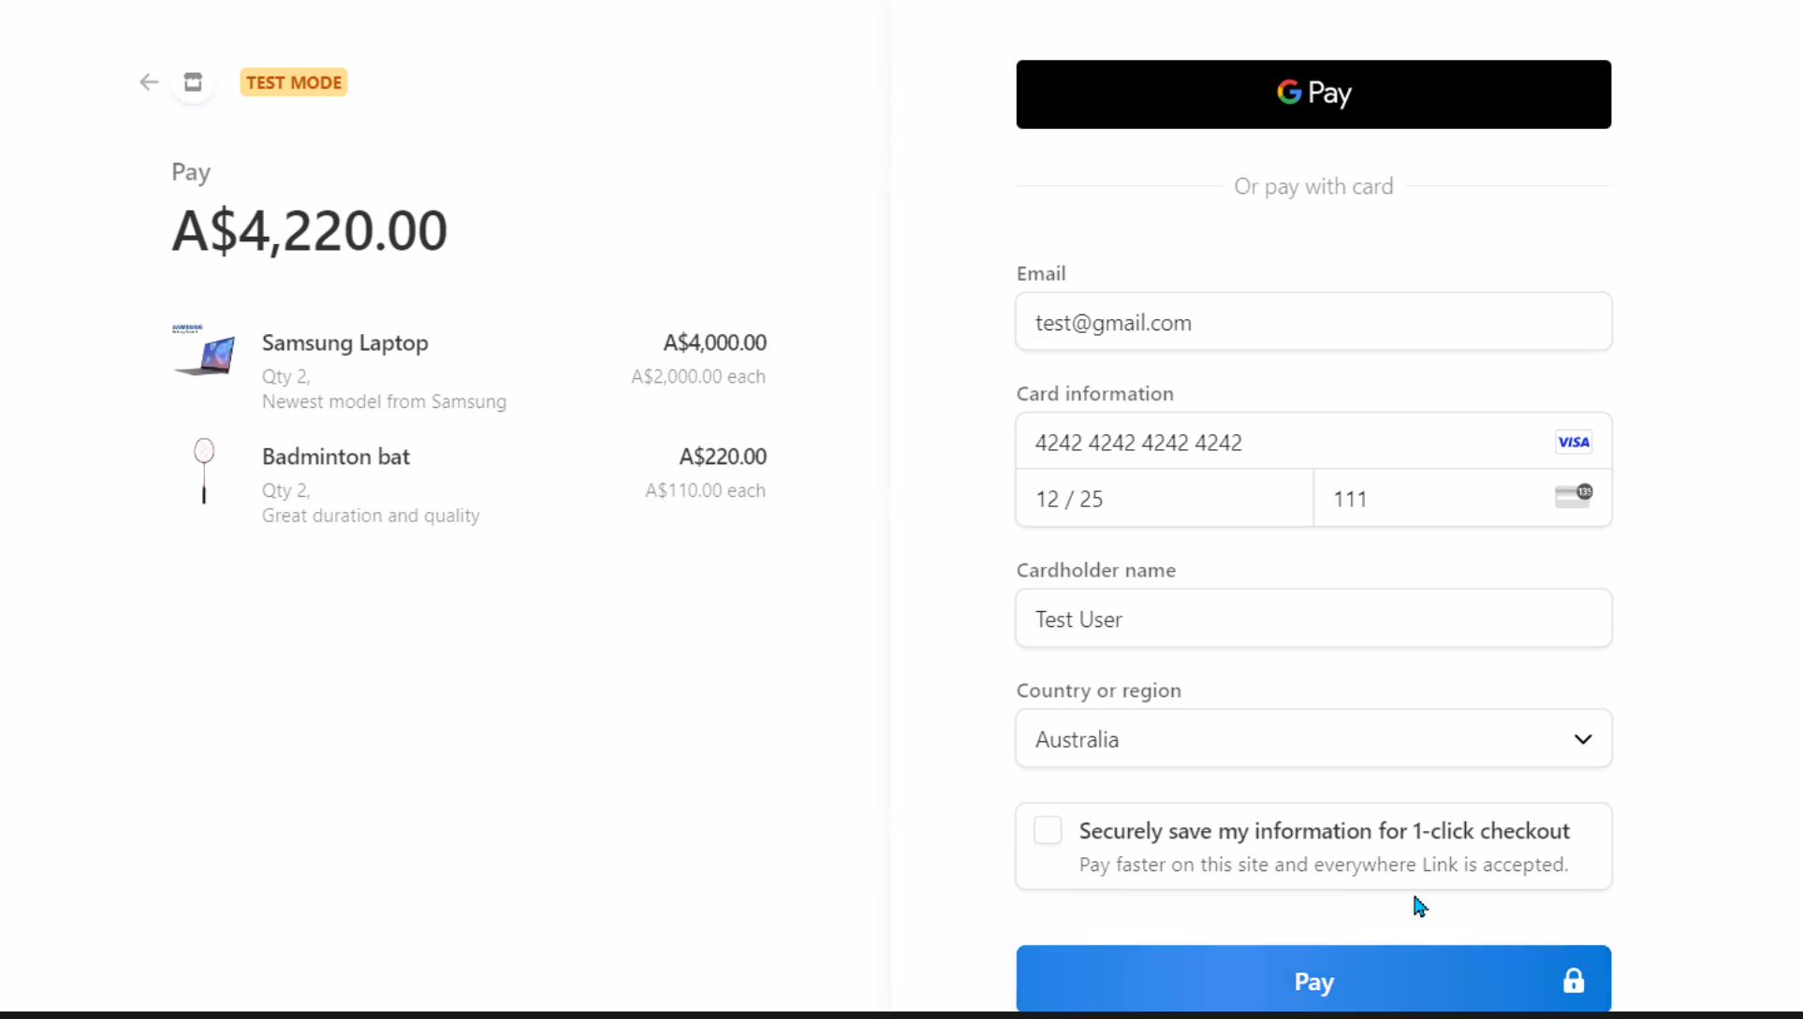

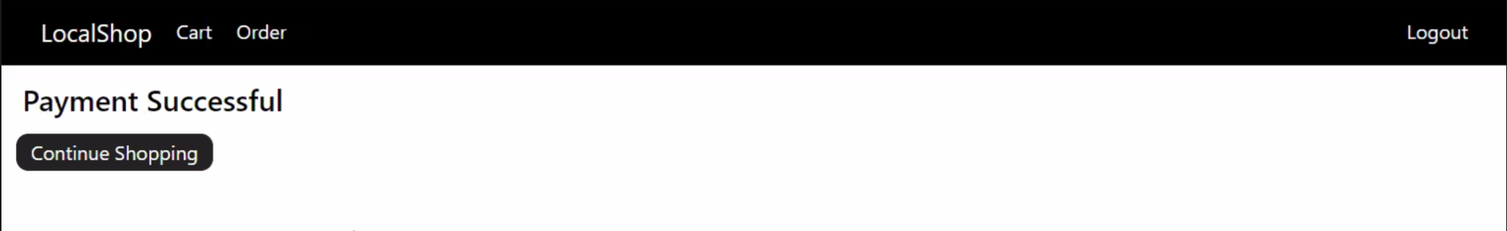

* View Purchased Orders:
  + They can view the order history page with the header by clicking the “Order” tab, which shows details and status of each order they have made.

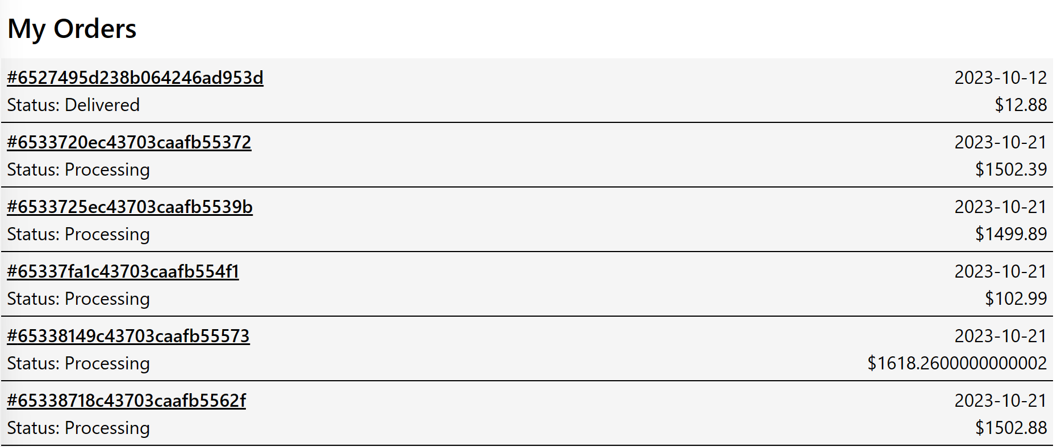

* + They can view each order by clicking it, showing more details and information on the products.

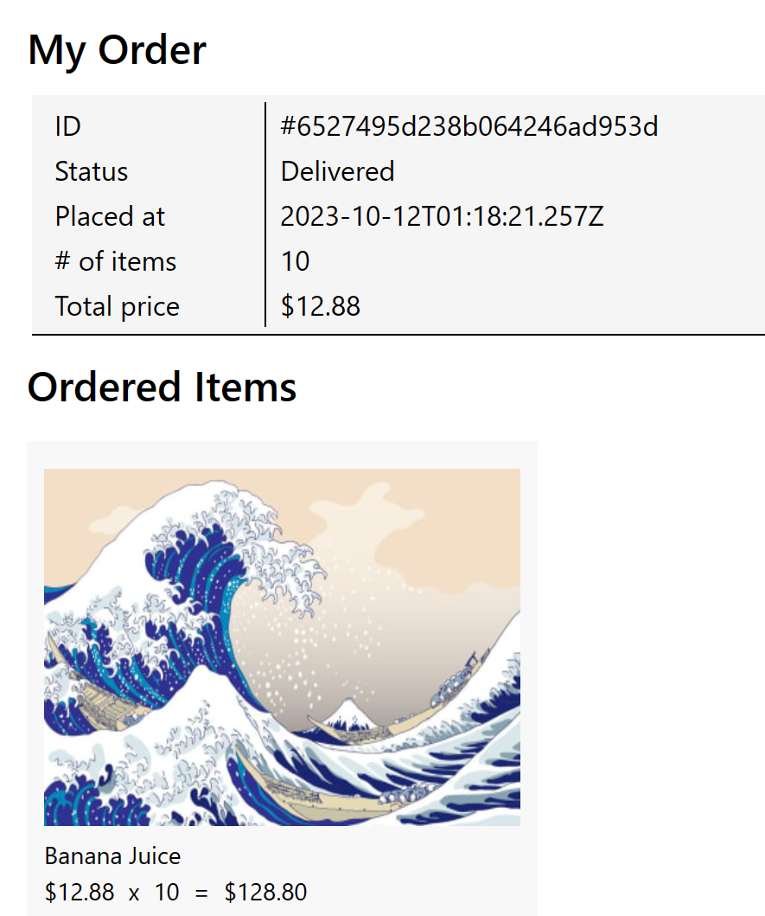

## Admin

* View Products:
  + Admins can see the home page with products, with different header than that of a normal user.

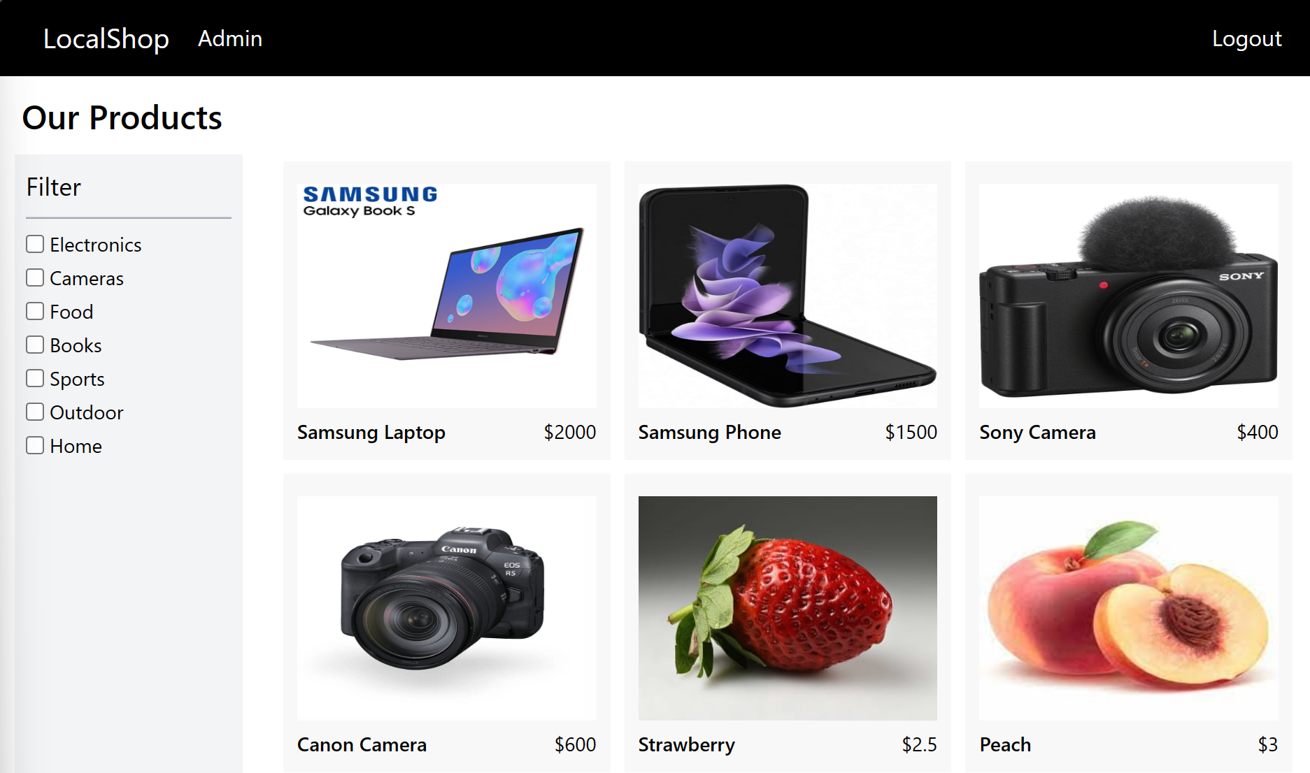

* + They can click on each product to see detailed information.

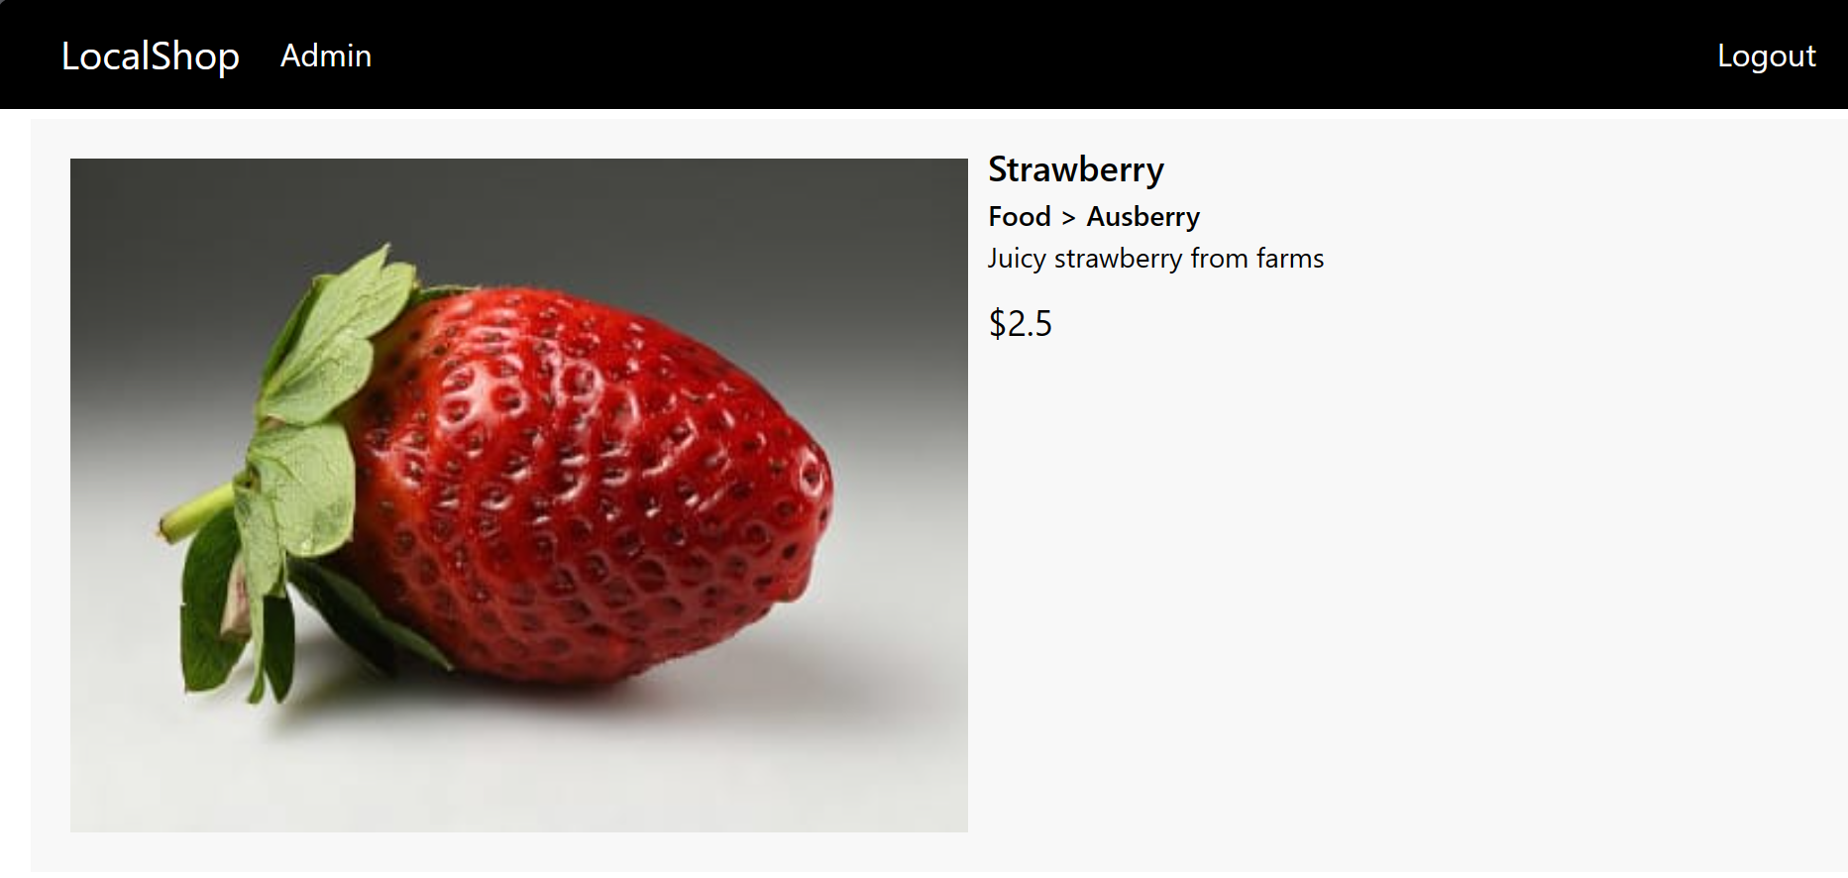

Admins can access the “Admin” tab in the header to perform the following actions, which displays a second smaller header:



* Manage Orders:
  + Admins can view the order page by clicking the “Manage Orders” tab and change the status of each order by choosing an option from the drop-down menu next to the “update” button, and hit the button to change the status.

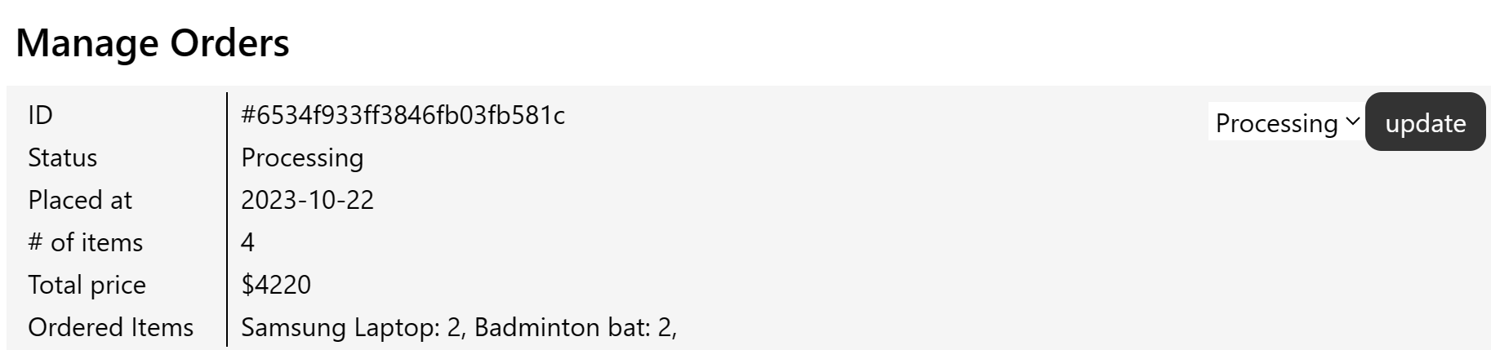

* Add Products:
  + Admins can access the add product page by clicking the “New Product” tab, then fill in the required information to add a new product.

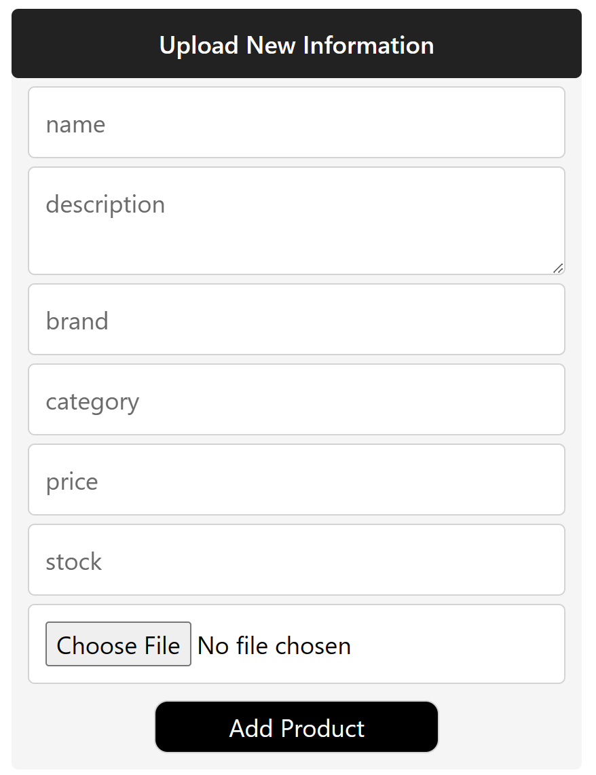

* Delete Products:
  + Admins can access the delete product page by clicking the “Manage Products” tab, then click the “delete” button.

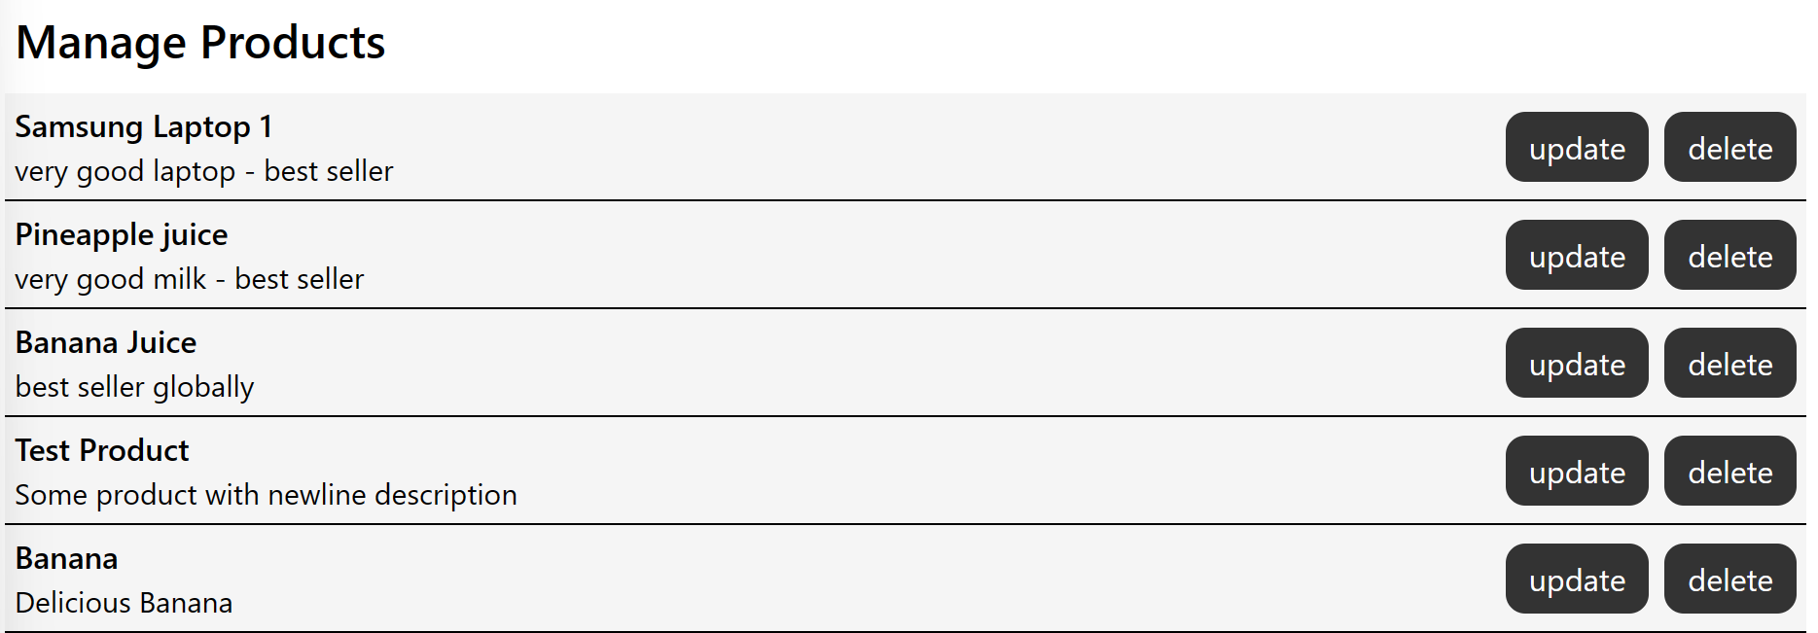

* Update Products:
  + Admin can update product details in the same tab as the “delete” button, by clicking the “update” button instead, which will display the update form. Admin can change any details and click “Update Product” to apply the changes.

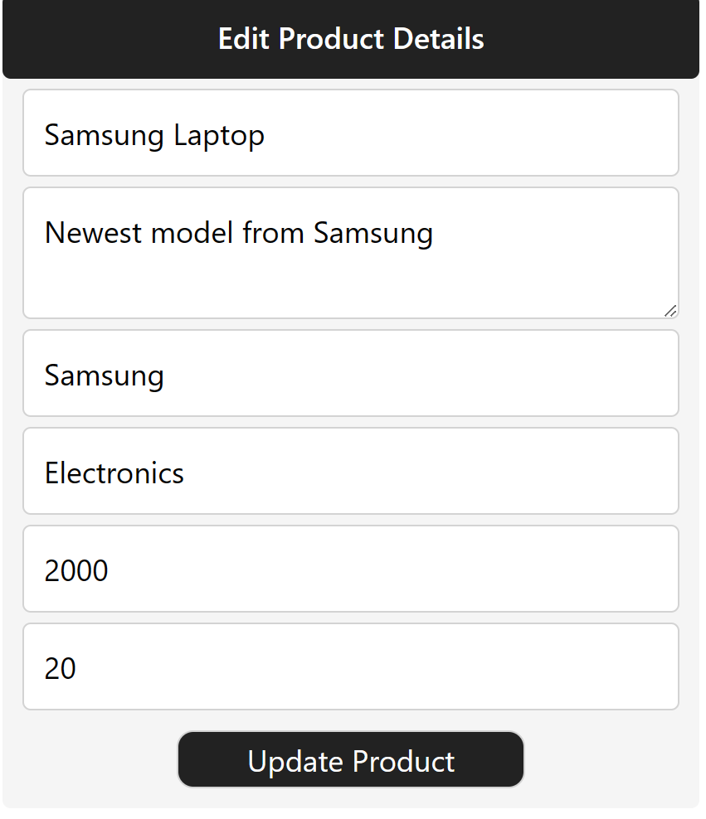

* Manage Users:
  + Admins can see the list of users recorded in the system by clicking the “Manage Users” tab. They can delete any accounts by clicking the “delete” button next to them.

